Create the following using JavaScript

**Output:(Before adding any task)**  
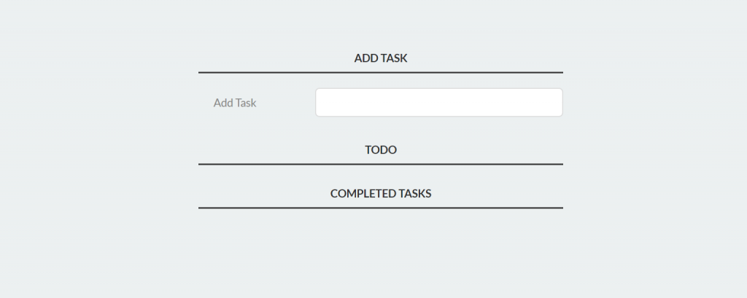  
**Output:(After adding task)**  
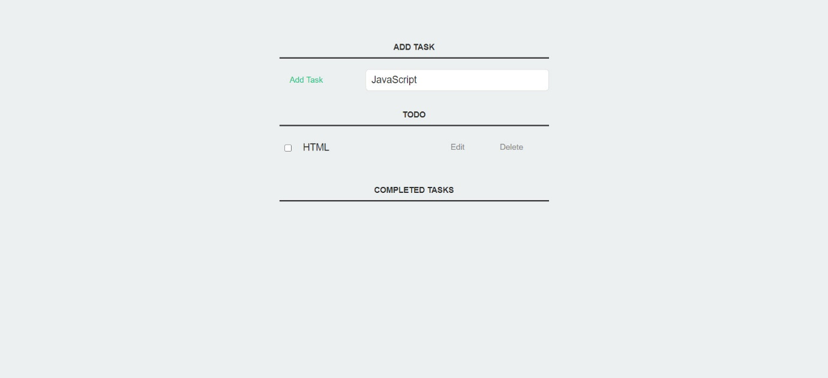  
**Output:(After Completing the task)**  
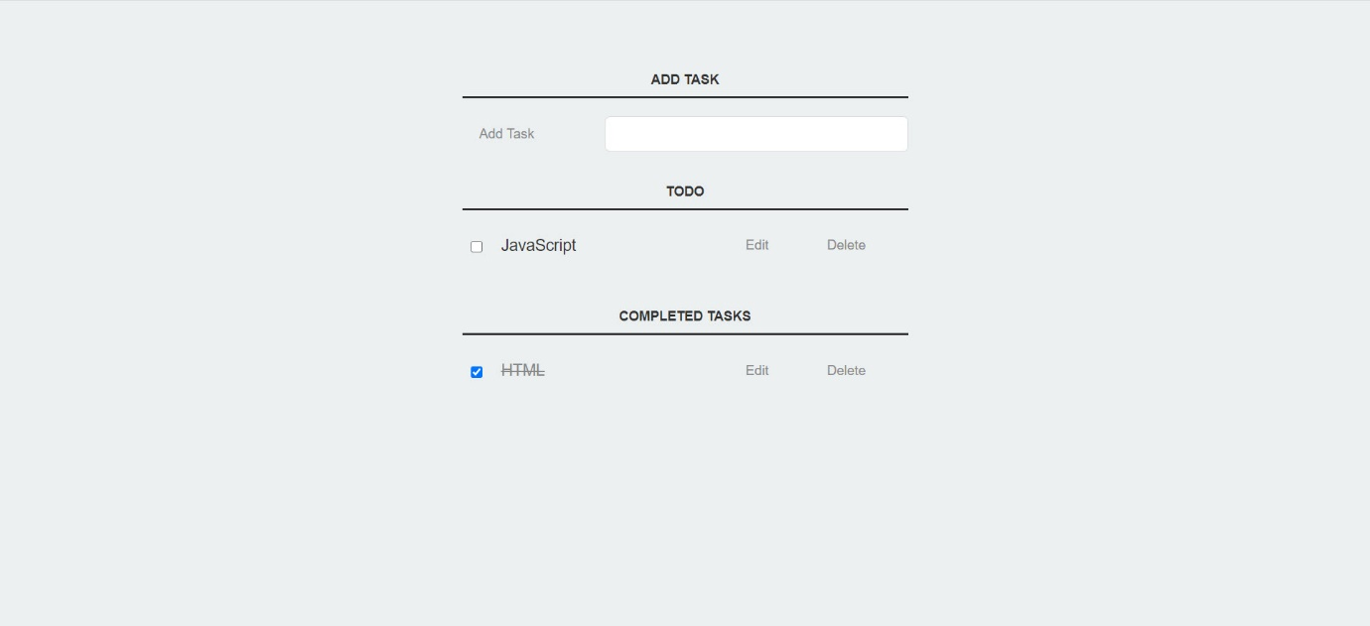

**To – Do Using JavaScript**

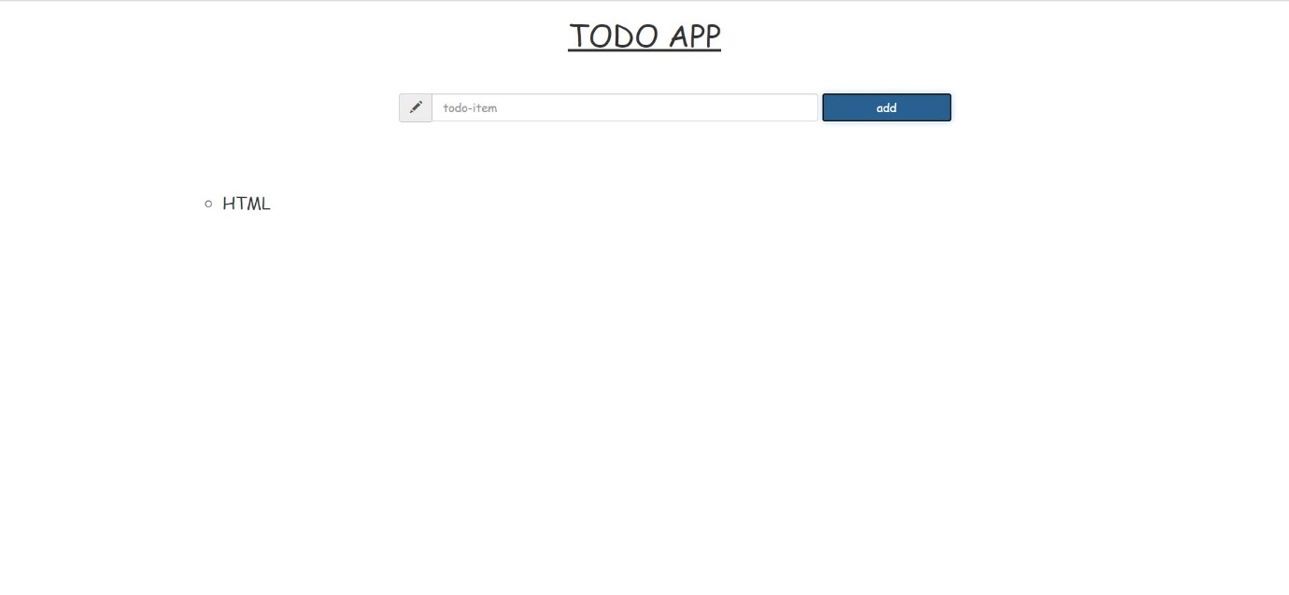

Create Dark/Light Mode for Website using JavaScript

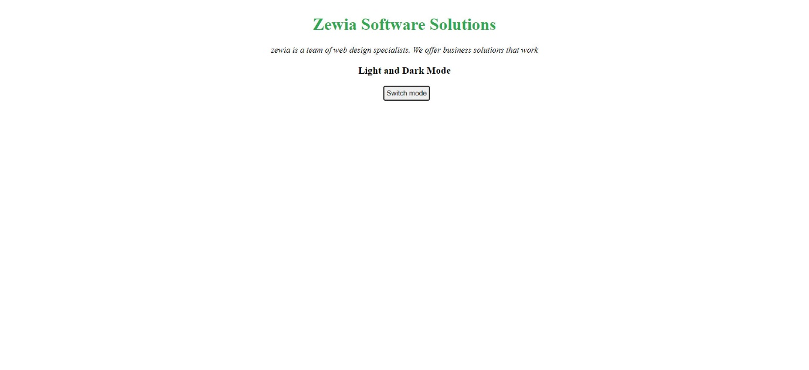

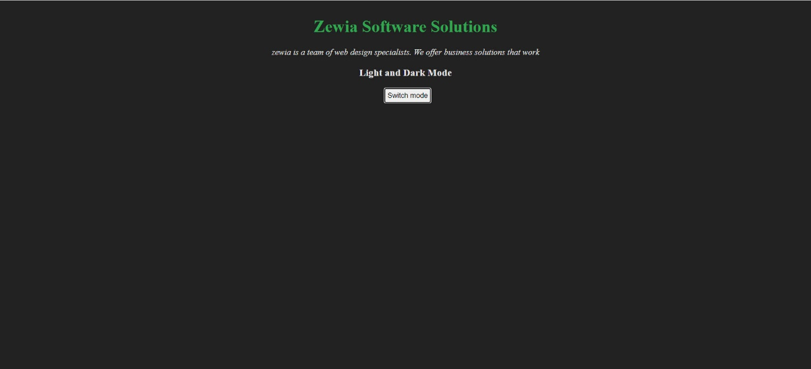

# Create Full Screen Navigation Bar using JavaScript?

# 

# 